Futures TipsAdapter Elimination – ONE_MAIN Test Case

Test Environment Setup
- Configure the environment for ONE_MAIN Session.
- Make sure the Local Xtp in the environment is configured for ONE_MAIN
- Check the extent map to verify a path exists between local XTP and the trade servers.

Test Scenario 1
- Bring up the Product State Maintenance dialog in the Admin GUI.
- Pick a class running under the ONE_MAIN session. We will pick AAPL for this test case.
- Change the state of the future products and strategy products for AAPL to Open. 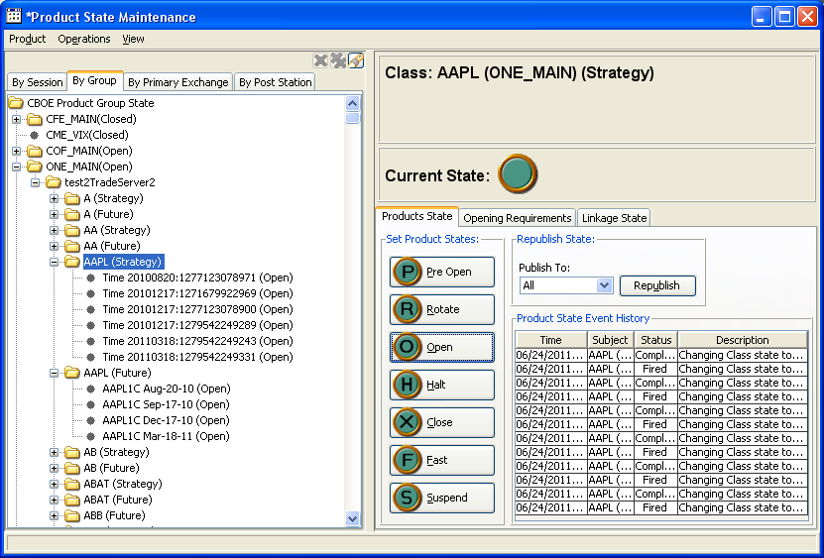

- From the local XTP fire a few open messages indicating trade for AAPL.
- From the local XTP fire a halt message for AAPL.
- Verify the state of the future products and strategy products for AAPL changes to Halted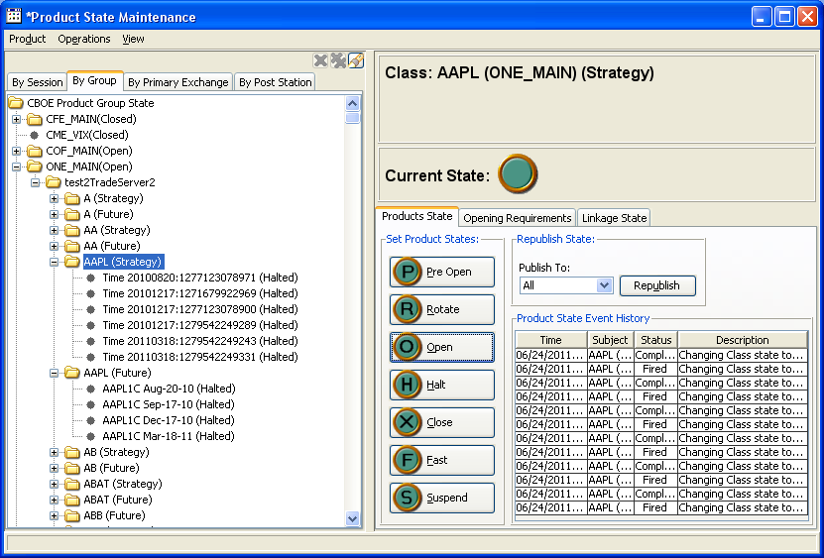
- From the local XTP fire a few open messages indicating trade for AAPL.
- Verify the state of the future products and strategy products for AAPL remains Halted

Test Scenario 2

- Bring up the Product State Maintenance dialog in the Admin GUI.
- Pick a class running under the ONE_MAIN session. We will pick AAPL for this test case.
- Change the state of the future products and strategy products for AAPL to Pre-open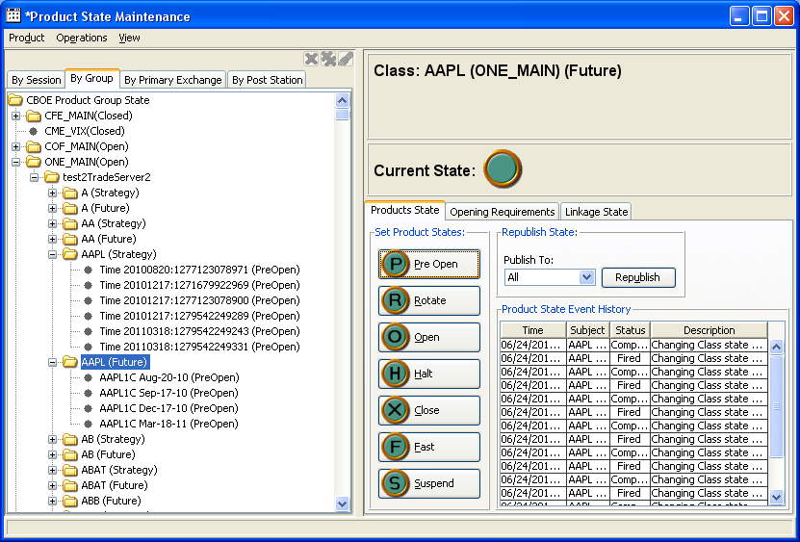
- From the local XTP fire a few open messages indicating trade for AAPL.
- Verify the state of the future products and strategy products for AAPL remains Pre-open

